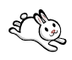

Bunny Funny

The bunny hops

The bunny shops.

He has a nickel.

He buys a pickle.

